User Assistance Documentation Retrieval – Observation Report

This document summarizes the analysis performed on the UA Documentation Retrieval tool within the Integrated Engineering Collaboration domain ( ICELB).
Query:
“What are the functionalities available in the Collaborate tab of the Extended Collaboration Dashboard?”

Expected Result
The system should retrieve:
- The document relevant to the user query i.e. (About the Extended Collaboration Dashboard and Access to Content) and the content URL is User Assistance R428rel/English
- Content specifically related to the Collaborate Tab
- And should retrieve all the content and subsections related to the collaborate tab they are,
  - 3DSwym
  - Project Planning
  - Bookmark Editor

Observations:
- When I run the query, the total responses retrieved is around 15 chunks which are mapping to different documents.
  - Among 15 chunks the 4 chunks belonged to the correct document “About the Extended Collaboration Dashboard and Access to Content” however, they had different similarity scores.
- Even though the correct document was retrieved:
  - The most relevant information was missing
  - Retrieved chunks did not fully cover the Collaborate Tab

Result:
- Chunk 1:
- It is referring to the exact document where the relevant information to the user query is present.
- Similarity Score: 47.61 (Highest)
- Content Covered: Beginning of the document up to the start of the Collaborate Tab
- Observation: Does not include any subsections of the Collaborate Tab
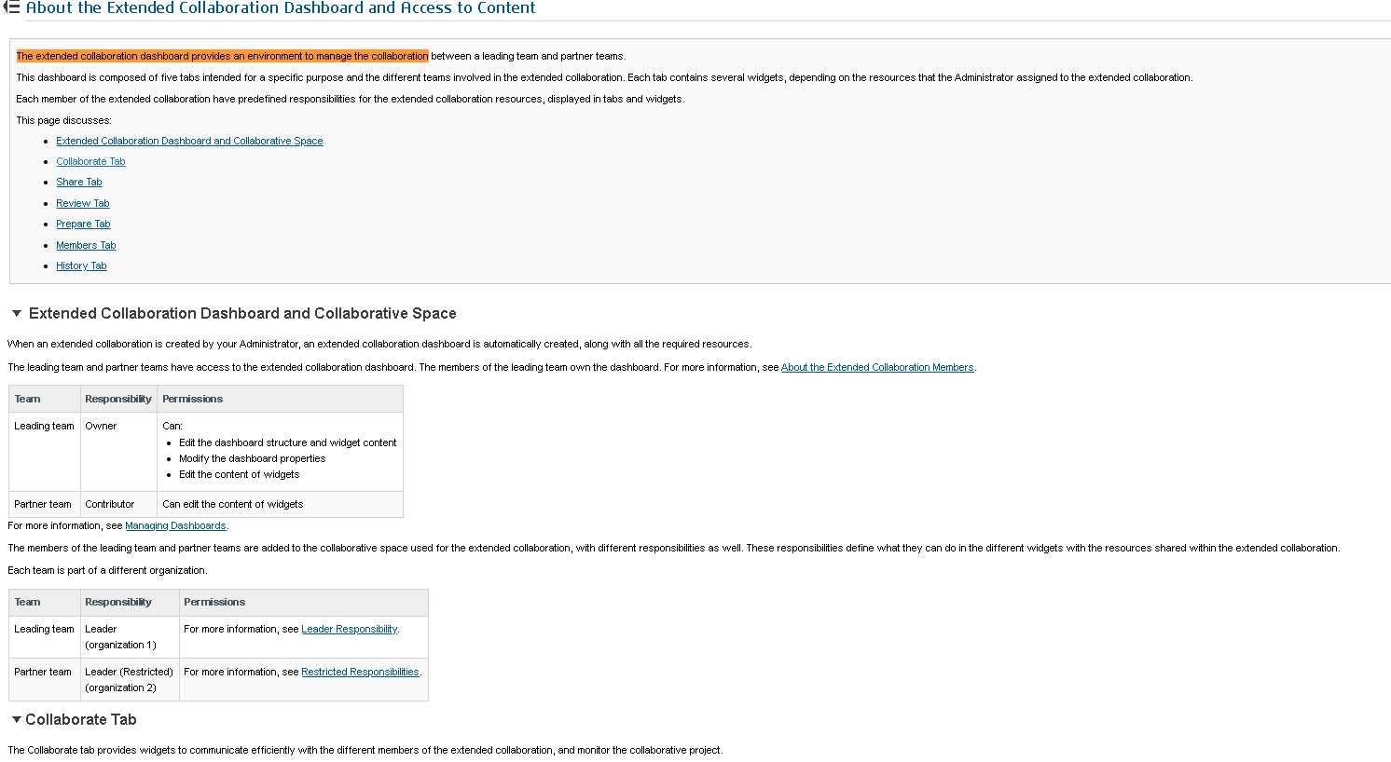

We expect that the next chunk which maps to the same document should retrieve the data from collaborate tab. But,
- Chunk 2: refers to the same document with,
- Similarity Score: 1.80
- Content Covered: Prepare Tab to partial Members Tab
- Observation: Content is not relevant to the query (Focus is outside the Collaborate Tab)
- Actually we are focusing on only collaborate tab since the query is about collaborate tab. But this chunk retrieved the info about prepare tab (seems irrelevant).

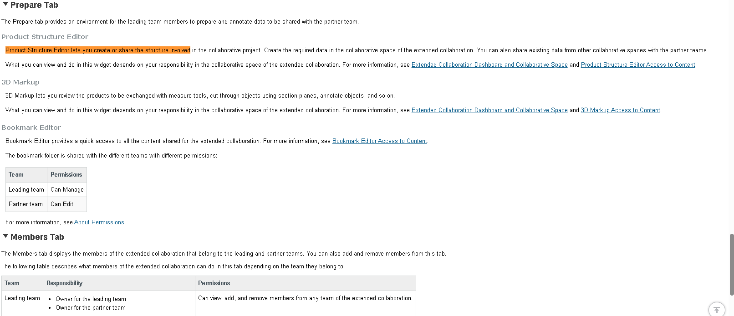

- Chunk 3: this chunk maps to the same document with,
- Similarity Score: 1.79
- Content Covered: Bookmark Editor (subsection of Collaborate Tab) to Share Tab
- Observation: Contains partial relevant information (Only one subsection Bookmark Editor is retrieved)
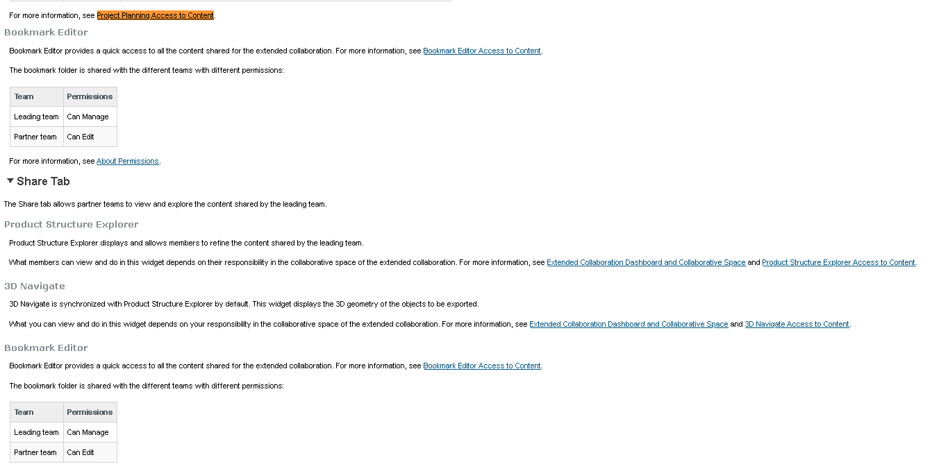

- Chunk 4: this chunk maps to the same document with,
- Similarity Score: 1.78
- Content Covered: Members Tab to History Tab (end of document)
- Observation: Completely irrelevant to the query (not retrieved info about collaborate tab)

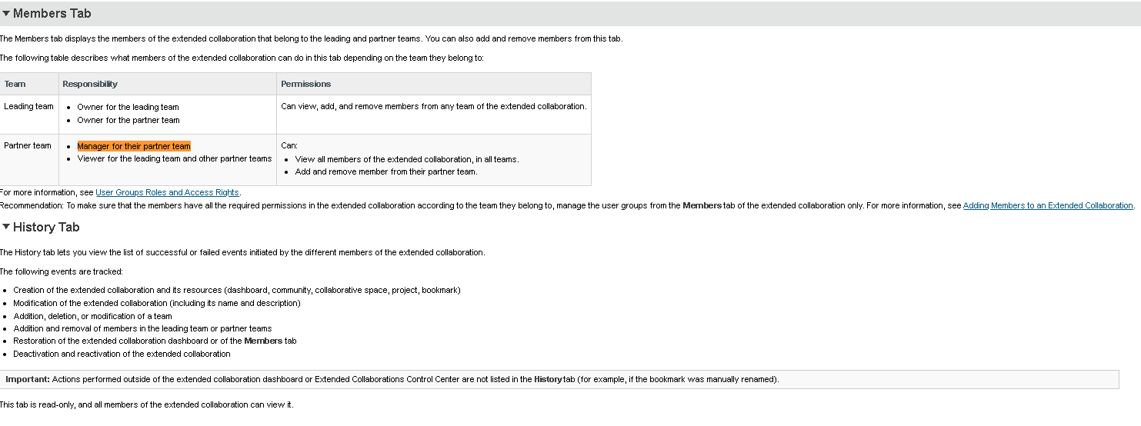
Note:
- Here the query is completely focusing on Collaborate Tab but the important information about the collaborate tab is missing.
- The system missed key subsections of the Collaborate Tab:
3DSwym
Project Planning
Only partial content of the collaborate tab was retrieved that is:
Bookmark Editor
Conclusion:
The system is able to identify and retrieve the correct document. However, it fails to retrieve complete and relevant content for the given query.

